Form C12

(Updated 5 February 2024)

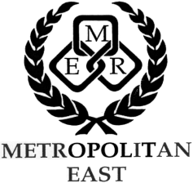

Metropolitan East School Sport
REGIONAL TRIAL REPORT

SPORT
CONVENOR
CONVENOR’S SCHOOL
DATE OF TRIAL
VENUE OF TRIAL

NUMBER OF STUDENTS PER DISTRICT  (One line per District Team eg. Composite 15yrs Boys) | District Name | Number of Students |  |  |  | Total
 |  | State |  | Non-State
 |  | M | F | M | F
 | First Nations Students
NUMBER OF DISTRICT OFFICIALS IN ATTENDANCE  (This is very important, please complete) |  | Number of Officials |  |  |  | Total
 |  | State |  | Non-State
STUDENTS IN ATTENDANCE | Attach all District Team Lists or list of Individual Nominees.
RECOMMENDATIONS
(Competition Format, Draw, teachers/officials used or required, etc.

(Please make recommendations about how to improve the regional trial)

NOTE: If you have made any amendments to your previously approved CARA document, you must submit the revised copy with this report.

Return to: Email: marisa.jones@qed.qld.gov.au

WITHIN ONE WEEK OF THE REGIONAL TRIAL

