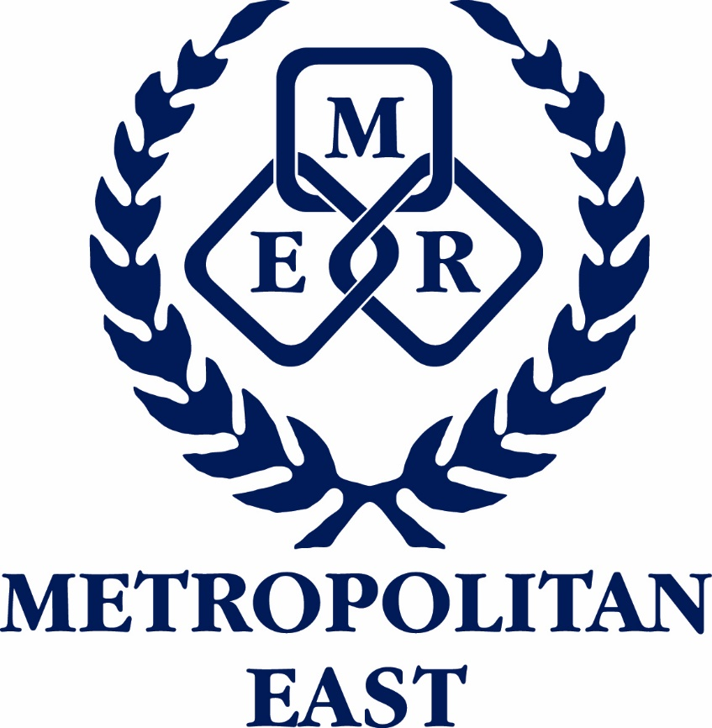
Metropolitan East School Sport
FORM C11
(updated 25 January 2023)
Team Made to Order Uniforms

THIS FORM MUST BE COMPLETED WITHIN 48HRS OF THE REGIONAL TRIAL TO ENSURE THAT MTO ITEMS CAN BE MADE IN TIME

List all team members on this form. If a team member doesn’t require any on field playing apparel place N/R in the playing number column. If students require more than 1 on-field playing item, it must be included on this form.

TEAM: |  | GENDER: | Boys / Girls | AGE LEVEL:
MANAGERS NAME:

NAME OF STUDENT | PLAYING NUMBER  (if required) | JERSEY / DRESS / SINGLET |  | RECEIVED | SHORTS / SKIRTS / BIKE PANTS |  | RECEIVED
 |  | QUANTITY | SIZE |  | QUANTITY | SIZE
eg Sam Smith | N/R

Forward completed form to: Metropolitan East School Sport Office

Email: Marisa Jones marisa.jones@qed.qld.gov.au

Please return this form IMMEDIATELY after the regional trial and playing numbers assigned.

