FORM C11
(updated 10 February 2026)
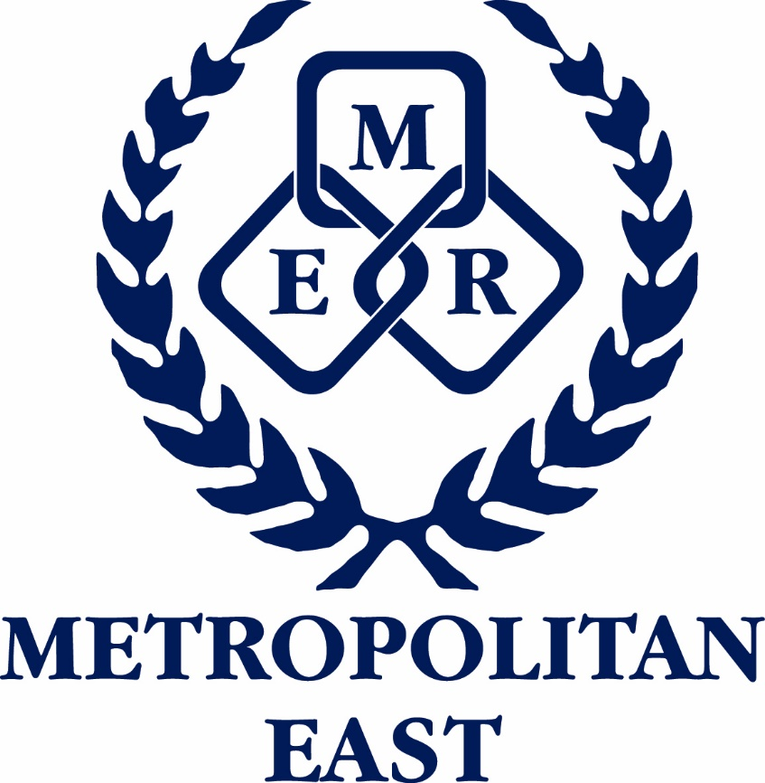
Metropolitan East School Sport
Team Made to Order Uniforms

THIS FORM MUST BE COMPLETED WITHIN 48HRS OF THE REGIONAL TRIAL TO ENSURE THAT MTO ITEMS CAN BE MADE IN TIME

TEAM: |  | GENDER: | Boys / Girls | AGE LEVEL:
MANAGER’S NAME:

List all team members on this form. If a team member doesn’t require any on field playing apparel place N/R in the playing number column. If students require more than 1 on-field playing item, it must be included on this form.

NAME OF STUDENT | PLAYING NUMBER | PLAYER NAME CONSENT  YES OR NO | JERSEY / DRESS / SINGLET |  | SHORTS / SKIRTS /BIKE PANTS
NAME OF STUDENT | PLAYING NUMBER | PLAYER NAME CONSENT  YES OR NO | QUANTITY | SIZE | QUANTITY | SIZE
** Make sure sizing is outlined correctly – eg K10, K12, S, M, L10, L12

Forward completed form to: Metropolitan East School Sport Office

Email: Marisa Jones marisa.jones@qed.qld.gov.au

Please return this form IMMEDIATELY after the regional trial and playing numbers assigned.

