**PROCESS FOR REGIONAL OFFICIALS TO ACCESS THE OFFICIALS APPAREL IN THE STRUDDYS ONLINE SHOP**

Struddys On-line Shop for officials: <https://struddys.com.au/partner-stores/schools/mess/>



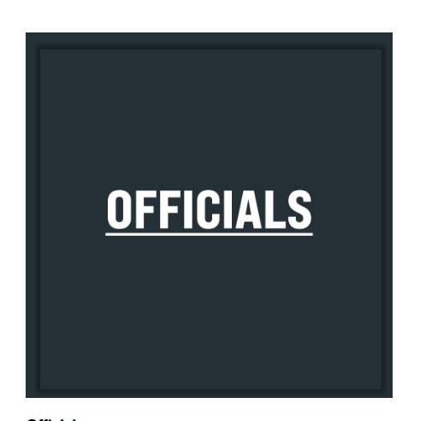

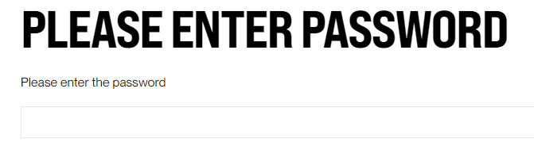

You will then need to input the Regional Officials Password to get into the shop.

This Password is **MERTOLDEU** and then press submit.

This is now where you can purchase your items. You will see all of the items available for officials to purchase.

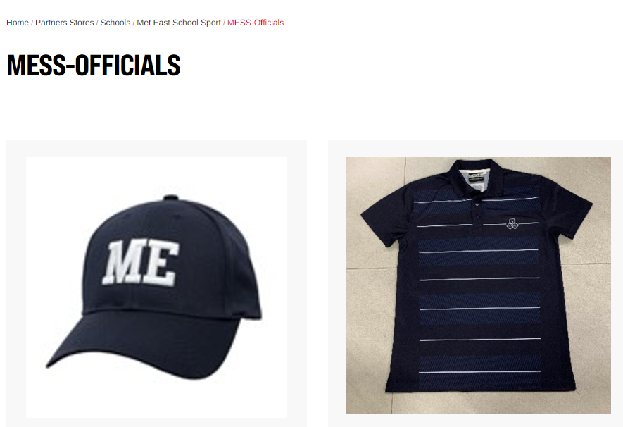

Once you’ve chosen all of the items that you wish to purchase, you will be able to apply the discount code below before paying.

All officials are entitled to a once off $40 Discount from the total price of the items that they’ve ordered.

The discount code is: ME25OFC

**This code can only be used once during the year. Struddys have a list of the officials and will be keeping track of who has used the code throughout the year.**

Your order will be shipped to your address, or you may choose to collect your order directly from Struddys.

For all enquiries regarding online ordering, please contact Struddys direct on PH: 3209 6100.